LOHANA SCHOOLS
BABY CLASS WORK TWO (ACTIVITY FOUR) 2020
Name: ……………………………………………………..Stream:…………
Developing and using my language appropriately.
- Read colour and copy.
s
c
- Match the same letters and copy.
a f ___________
b e ___________
c a ___________
d b ___________
e c ___________
- Put the missing parts.

- Match the same pictures
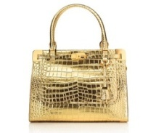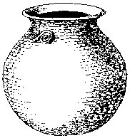


- Copy these letters.
b | c | a | d | f | e

- Sound and write.
- Sound and write.
a + i p

a

- Circle the same.
S + S
i i n
p o p

- Match the same.
S i a n
t s
p a
n t
i p
- Circle the same pictures.
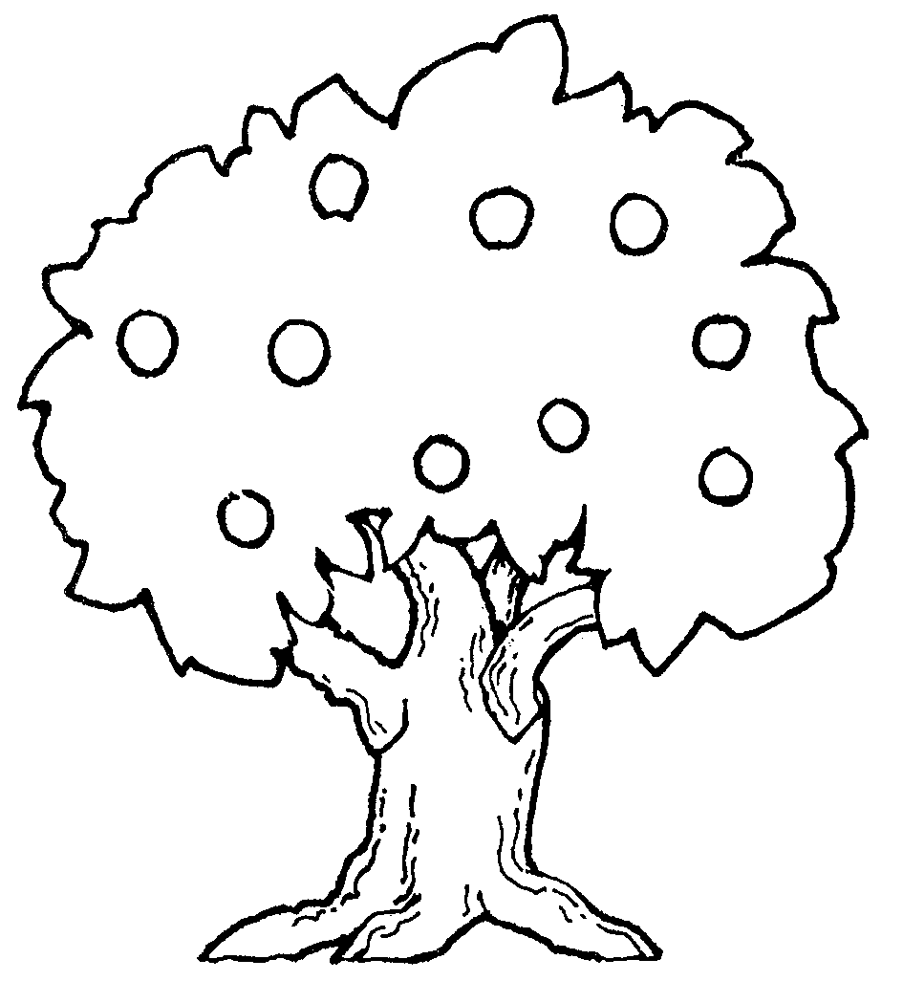
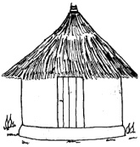


- Copy and learn.

_________________________________________________
_________________________________________________
_________________________________________________
_________________________________________________
_________________________________________________
_________________________________________________
________________________________________________

Copy and learn.

_________________________________________________
_________________________________________________
_________________________________________________
_________________________________________________
_________________________________________________
_________________________________________________
_________________________________________________
_________________________________________________

Copy and learn.
____ _____ ______ _____

- Developing and using mathematical concept in my day to day experience.

Shade the shapes.

- Count and write.

0 1 2 3

4 5

- Match the same shapes.

- Match the same numbers and copy.
- 5
- 4
- 1
- 2
- 3
- Circle the same numbers.

2 3

0 2 3 9
1 5

6 7

6 0 8 2
4 7

- Interacting with Exploring knowing and using my environment.

Shade a cup.


Draw a cup.

- Colour a pot.



Draw a pot

- Match things at home.
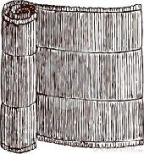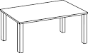

Shade a cat.
